
118.5 volunteer hours
29 involvement hours
57 overall engagements
Quarterly Report
Quarter 2: Jul – Sep 2021

Healthwatch Wigan and Leigh is the independent champion for people who use health and social care services.
We’re here to make sure that those running services put people at the heart of care.

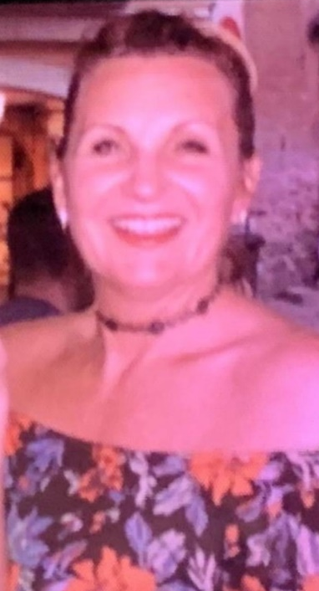
Message from our Chief Officer

“Healthwatch Wigan and Leigh is the independent champion for people who use health and social
We’re here to make sure that those running services put people at the heart of care.
We’re here to make sure that those running”

Karen Parker
Healthwatch Wigan and Leigh Chief Officer

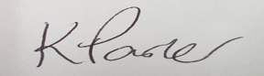
people made information and signposting enquiries this quarter
9
training sessions were attended by staff this quarter

70


Post Interactions
11472
8023
Post Impressions
12
New Followers

4 increase since last quarter!
3120 increase since last quarter!
8407 increase since last quarter!


56
555
62000

New Followers
Tweet Interactions
Tweet Impressions

20 increase since last quarter!
131 increase since last quarter!
39,000 increase since last quarter!



30
14,664
20,253

New Users
Website Views
New Website Articles

Meetings attended this quarter
86
External meetings





Speaking up about your experiences of health and social care services is the first step to change.
Take a look at how your views have helped make a difference to the care and support people receive in Wigan & Leigh.



Patient Story: Mabel’s Hospital Discharge Experience (July 2021)
Mabel was a patient on Ince ward, RAEI.
On Monday 12th July Mabel was given a provisional discharge for the following day. She told the ward staff that her daughter could take her home at midday on 13th July.


On 13th July she was discharged at 9.15am. Again, she explained that her daughter could collect her at midday. Her daughter kept ringing the ward as she is a school teacher and would be taking time out of school.


At around 1.30/2pm the ward sister informed Mabel that she could go home and was being moved to the Discharge Lounge. Mabel refused and when asked why, explained that she had two previous poor experiences of the Discharge Lounge.


Mabel finally got her discharge letter and medication at 6.15pm and went home at 6.30pm.

Mabel is aware of two other patients who were also told they could go home:

• Lady 1 – Had a plural drain removed the day before and was still in pain. Her husband was a retired consultant and she said she would go home and her husband would come back the following day for her medication
• Lady 2 – Was also in pain went to the discharge lounge. She had to sit with a mask on. She got her medication at 6.30pm and she had to wait for a taxi to take her to Leigh. She got home at 8.30pm.

Advice & information articles produced this quarter

NHS Covid Pass - what is it and how do I get it?
https://healthwatchwiganandleigh.co.uk/advice-and-information/2021-07-21/nhs-covid-pass-what-it-and-how-do-i-get-it

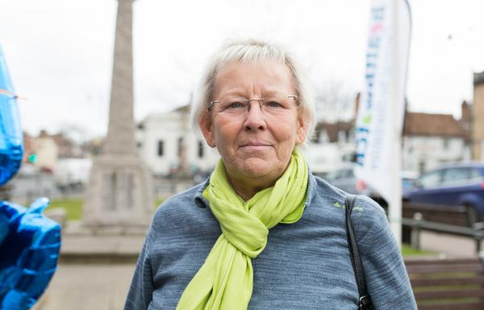
Avoiding falls - elderly fall prevention
https://healthwatchwiganandleigh.co.uk/advice-and-information/2021-07-26/avoiding-falls-elderly-fall-prevention



Accessing mental health support
https://healthwatchwiganandleigh.co.uk/advice-and-information/2021-08-04/accessing-mental-health-support


Getting an autism diagnosis and assessment
https://healthwatchwiganandleigh.co.uk/advice-and-information/2021-08-04/getting-autism-diagnosis-and-assessment



How do I get a social care needs assessment?
https://healthwatchwiganandleigh.co.uk/advice-and-information/2021-07-27/how-do-i-get-social-care-needs-assessment


What is Continuing Healthcare?
https://healthwatchwiganandleigh.co.uk/advice-and-information/2021-09-01/what-continuing-healthcare



What are Personal Health Budgets?
https://healthwatchwiganandleigh.co.uk/advice-and-information/2021-08-31/what-are-personal-health-budgets


What can your NHS dentist do for you?
https://healthwatchwiganandleigh.co.uk/advice-and-information/2021-08-24/what-can-your-nhs-dentist-do-you

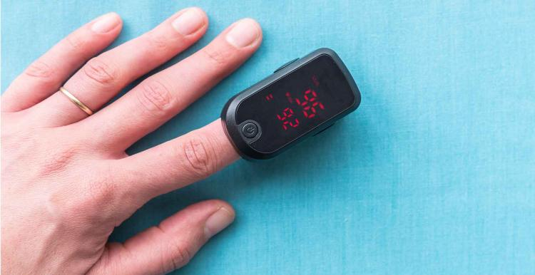

Covid Oximetry @home
https://healthwatchwiganandleigh.co.uk/news/2021-08-10/covid-oximetry-home


Prostate cancer – know the facts
https://healthwatchwiganandleigh.co.uk/advice-and-information/2021-09-06/prostate-cancer-know-facts

Patient Story: Jenny’s Prescription Access Experience (July 2021)
Jenny is in temporary accommodation out of her GP area and is in need of her regular prescription.

Access to a GP

Jenny contacts her GP practice for her repeat prescription and is told she has been de-registered as she is now out of area. She is told to register with a local practice, who refuse because she is only in the area temporarily.
Jenny asks Healthwatch (HWWL) for help as her medication is due the following day.

Solution

Healthwatch contact her practice to explain her situation. The practice advises that it will make a note on their system of Jenny’s situation
Prescriptions should be requested with 2 days notice and will be sent to a pharmacy near to where she is staying.

Problem

Jenny telephones HWWL the following day to say she can't remember which pharmacy she should go to.
HWWL contact her GP practice who say she has been deregistered. HWWL explain previous days conversations and receptionist realises records have not been updated.
Jenny is informed which pharmacy to collect meds from.

Access to a GP
Jenny rings HWWL as her prescription is incorrect and asks us to contact GP practice. Her anxiety is heightening.
Practice explain that she has been put on weekly prescriptions and if Jenny wants to speak to GP she should go through AskmyGP.
This is not possible for Jenny so receptionist agrees to put a request in through AskmyGP for GP to contact Jenny.

Communicating

Charity supporting Jenny contact HWWL. They have called urgent response team
They try to update her GP record but it is showing has Jenny been de-registered
Urgent response team refuse to post or telephone update to GP practice
Jenny is panicking that her next prescription will not be at pharmacy on due date
HWWL confirm with practice that script has been sent and registration is fine



Jenny has several health conditions, including anxiety, and is panicking that she will be without medication. She is living in temporary accommodation with limited funds and has a pay as you go mobile for communication.
Her experience raises the issue of people being placed in temporary accommodation having access to their own GP. Jenny is happy with her GP, who she has been registered with for a very long time, and she is happy with the support she usually receives from the practice.
Jenny’s experiences highlight the problems caused when people temporarily move out of their local area. The GP may deregister them and instruct them to find a GP closer to where they are in temporary accommodation. The communication between practices is poor and slow and people often go without important medication while arrangements are being made.



Training attended this quarter
September
August
July

Andrea Arkwright, Engagement Officer
Introduction to Healthwatch

Lisa Armstrong, Engagement Officer
HWE Models of Engagement

Andrea Arkwright, Engagement Officer
Volunteer Lead Network

Ellen Darbyshire, Communications & Information Officer
How to write a communications strategy

Lisa Armstrong, Engagement Officer
Undertaking research and engaging with seldom heard groups
Ellen Darbyshire, Communications & Information Officer
Making the most of your social media channels

Karen Wilson, Senior Engagement Officer
Public Sector Equality Duty
Identifying Outcomes and Taking Impact

Lisa Armstrong, Engagement Officer
Identifying Outcomes and Taking Impact

‘I’ Statements

These ‘I’ statements are common direct quotes from Wigan and Leigh residents, expressing their thoughts and desires for health and social care services.

I want professionals to check that I understand what they have told me
I want to speak to a human
I just want to register with an NHS dentist

I just want face to face appointments with my doctor
I just want to be listened to
I want people to ring me back when they say they will

Information & signposting
Homeless Engagement Projects
In July, our Engagement Officers Andrea and Lisa visited The Brick in Leigh and the Mercure hotel in Wigan, two overnight shelters for homeless people, to speak to them about their experiences of accessing health and social care in Wigan and Leigh during the COVID-19 pandemic.

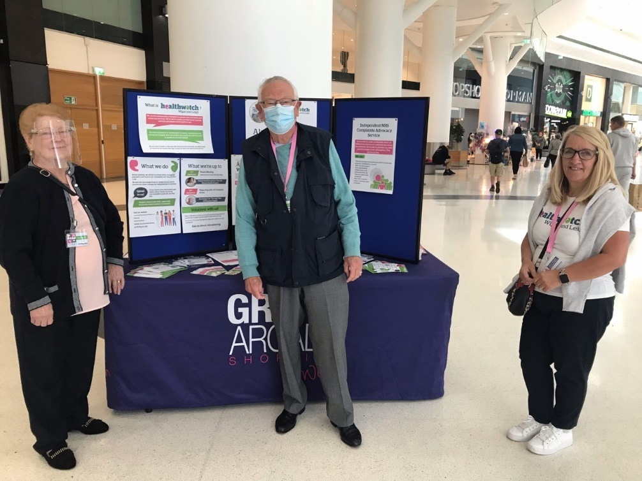
World Alzheimer’s Day Event

Tuesday 21st September marked World Alzheimer’s Day, an international awareness day to spread information and resources about dementia. The team, along with some of our fantastic volunteers, spent the morning at Wigan Grand Arcade offering information about the disease, as well as local support and resources, and gathering general feedback on health and social care from the public.

Wigan Cohesion, Inclusion & Equality Event

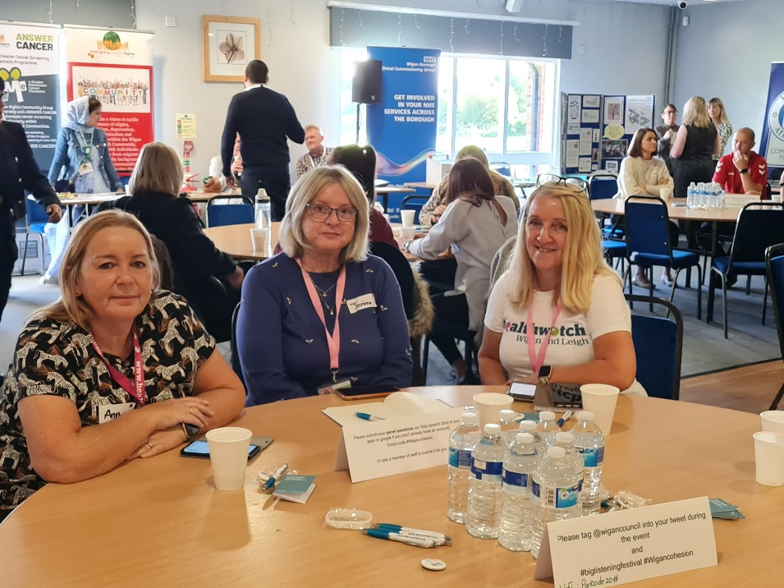

The team and our volunteers were delighted to attend the Wigan Cohesion, Inclusion and Equality Event in September. It was an excellent opportunity for the community to come together and learn and listen to find out how we can build community cohesion.
They heard some wonderful speakers and started some powerful conversations.

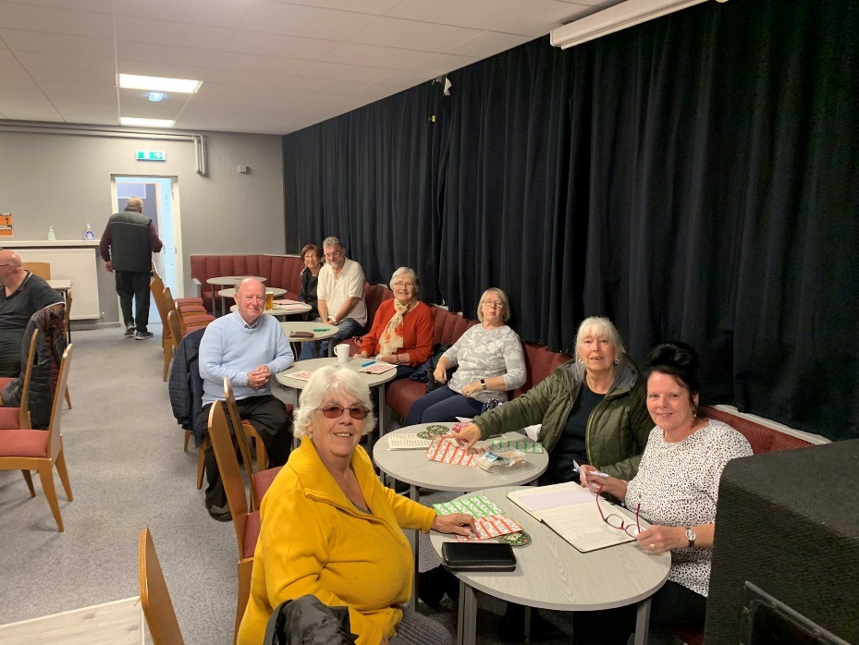
Ashton Deaf Club Bingo Night

Our Engagement Officer Andrea had a fantastic time engaging with the members of Ashton Deaf Club at one of their bingo nights in September.
Andrea shared with them some information about what we do at Healthwatch Wigan and Leigh, and will be back soon to continue to collect their experiences on GP access and urgent and emergency care for mental health.

Some members also asked for support and advice in writing letters of complaint from the independent NHS advocacy service we provide, which we will be happy to provide.

Upcoming Information & Signposting Days…

- World Mental Health Day at Spinning Gate Shopping Centre (OCTOBER)
- Reconnect Wigan Borough Convention (OCTOBER)
- Mental’s Health Awareness Event at Wetherspoons (NOVEMBER)
- Complete Kindness Café in Tyldesley (JANUARY)

- Accessing an NHS dentist
- Alzheimer’s Disease and Dementia
- Changing a trans person’s name and gender on NHS records
- Covid Oximetry @home
- Elderly fall prevention
- Getting an autism assessment and diagnosis
- Local mental health services for adults

- Local mental health services for children and young people
- NHS Covid Passes
- NHS continuing healthcare
- NHS Dental Services
- Pharmacy services FAQs
- Social care needs assessment
- Sunflower lanyard & hidden disabilities

Factsheets produced this quarter

Our work plan priorities

Urgent and Emergency Care in a Crisis (Adults and Children) Project
Our Engagement Officer Andrea Arkwright has been working on a project to collect people’s experiences with accessing urgent and emergency care for mental health

Priority One: Mental Health

- A communications poster was designed and circulated to NHS organisations, the voluntary sector, and social media
- Patient experience stories are starting to be told, with the themes of information and communication emerging
- Andrea met with the Wigan Armed Forces HQ to discuss veterans’ mental health, and there was a call for NHS staff to be educated on how to care for patients with PTSD
- She also attended an event at the Mental Health Support Club in Atherleigh Park to find out what their service offers and speak with the clients using the services


Priorities Two & Three: ICS & Inequality
Accessing Care through GP Services Project
Lisa Armstrong, Engagement Officer, has been exploring inequalities in health and social care and the integrated care system via a project on GP services and access

- Exploring how patients are choosing to access their GP (e.g. accessing services via digital platforms or over the phone)
- Discovering what the hurdles are to GP access and any difficulties making appointments
- Finding out what impact the shift to digital consultations has had on service users and service providers, and if the quality has been affected
- Finding out if any particular groups of patients have been even more marginalized
- Volunteers have phoned every GP Practice and reviewed every GP Practice’s website to find out what the patient experience is like, and what information is available
- Lisa has spoken to clinical professionals, patients from every primary care network in the Borough, PPG groups, and also homeless people, veterans, and deaf people


Priority Four: Quality
Experiences of Hospital Discharge and Continence Services
Chief Engagement Officer Karen Wilson has been working on projects to collect people’s experiences of being discharged from hospital to home, and continence services

Experiences of Discharge to Home

- Finding out if people’s experiences of being discharged from hospital to home was safe, timely, and well coordinated
- Working with Pensioners Link to follow up with their Home Safe clients
- Recruited volunteers to gather experiences
Experiences of Continence Services

- Set up a small project group of HWWL, Clinical Manager and Service lead, Commissioner & Embrace Wigan and Leigh
- Shared information through networks, service and social media channels and shared text service to collect feedback
- Feedback from Provider
- Report to be agreed, published, and circulated

Transformations

Urgent and Emergency Care
We continue to share patient experiences and the reasons the public may be accessing emergency care and appear to be self-presenting at A&E.

We continue to share patient experiences and have started to develop a series of ‘I’ statements.
We have been invited to join SDF Touchdown meetings.
Community Services Review – Clinical Reference Group

Advisory Committee

This quarter, we introduced the Advisory Committee, which will review details relating to Healthwatch in detail and make recommendations regarding its independence, transparency, and openness. The first meeting was held on September 14.

It will play an important role in contributing to Wigan Borough Healthwatch CIC strategic direction, analysing information and data that is received through the day to day work of Healthwatch.

It will make recommendations to the Board on areas of work on which to concentrate. Information will be supplied to the Advisory Committee via the Healthwatch team.


The Advisory Committee is made up of 14 members – 12 of which are new to Healthwatch – and each member is a Wigan Borough resident, or has a connection with the Borough.

They are from a range of backgrounds with a range of relevant skills and experiences, and were recruited in an open and transparent way.

Next steps:
- Elect a chair (to be appointed at the October meeting)
- Appoint a Healthwatch Wigan and Leigh representative to the Health Scrutiny Committee
- Agree Terms of Reference
- Agree Decision Making Criteria

Next Steps for Quarter Three

Engagement
- To complete the Discharge to Home project
- To further develop the Advisory Committee
- To develop engagement opportunities in collaboration with Healthier Wigan Partnership
- To develop engagement opportunities in collaboration with Wigan Borough Clinical Commissioning Group
- To support the Mental Health Response Care Team with engagement
- To attend various NHS professional meetings and the voluntary sector to promote projects
- To analyse the Access to GP project data and produce and circulate a report

Volunteering
- To plan and deliver a volunteer recruitment campaign
- To involve local students in voluntary work and mentor them to deliver a project/piece of work
- To offer additional training sessions to volunteers, e.g. training on report writing
- To develop new voluntary roles, e.g. a Social Media Volunteer, Engagement Volunteer, Information & Signposting Volunteer, or Graphic Design Volunteer
- To apply for the Queens Award for Voluntary Services 2023

- To create a communication strategy for Healthwatch Wigan and Leigh
- To write and release press releases
- To upload recordings and livestreams of our events and meetings to our social media channels and website
- To produce four factsheets each month and expand the resources library
Communications

Keep up to date with what we do next!

Visit our website:

www.healthwatchwiganandleigh.co.uk

Follow us on Facebook:

www.facebook.com/HealthwatchWL

Follow us on Facebook:

www.twitter.com/HWWiganLeigh

Contact us




Call us:

01942 834666


Email us:

info@healthwatchwiganandleigh.co.uk


Post to us:

Ashland House
Dobson Park Way
Ince-in-Makerfield
Wigan
WN2 2DX

