Home Care Report

Background and contents
Contents | Page number
Introduction and Background | 1 – 2
Method | 3 – 4
Demographics summary: Home care users | 5 – 6
Results:
Care arrangements | 6 – 7
Care plans | 8 – 9
Carers | 9 – 17
Time keeping | 17 – 19
Changes to care | 19-20
Missed visits | 20 – 21
Home care managers | 20 – 25
Care staff | 25 – 37
Demographics of care staff | 37 – 39
Rob’s story | 39 – 42
Conclusions | 41 – 43
Recommendations | 43 – 44
Acknowledgements | 44

Introduction and background
Healthwatch Wigan & Leigh is your local health and social care champion. Healthwatch Wigan and Leigh are the independent voice for the people of the Wigan Borough. We are the independent ‘consumer champion’ for health and social care. We exist to help the people of this borough to have an influence and a powerful voice in how services are run and how they can be improved. The map shows the seven Primary Care Networks (PCN’s) across Wigan Borough. A PCN is where General Practices work together with community, mental health, social care, pharmacy, hospital, and voluntary services in their local areas in groups of practices.
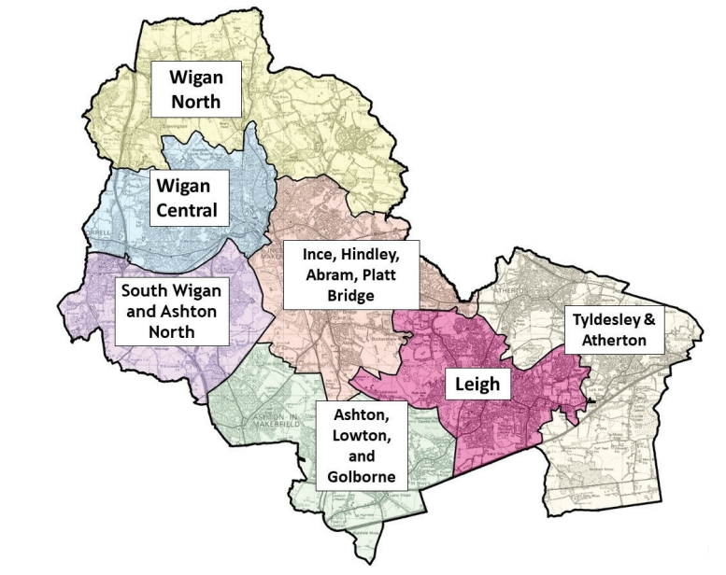

Healthwatch Wigan and Leigh exist to:
- Help people to make informed choices about health and social care options available to them.

- Listen to the views and experiences of local people about the way health and social care services are commissioned and delivered.

- Allow the people of this borough to have influence and a powerful voice in how services are run and how they can be shaped and improved.

- Influence how services are set up and commissioned by having a seat on the local Health and Wellbeing Board

- Share local intelligence with Healthwatch England and the Care Quality Commission
Home care services are an important element of community health and social care support. They are vital in keeping some residents of the borough living in their own homes and communities therefore delaying or preventing the need for some people to go into long term care.
Anecdotal information finds its way to Healthwatch via concerns raised with us or when people seek advice and information. At our recent Priority setting workshop, it was raised by all groups as an important area for review as it is a largely invisible service delivered in people’s own homes and therefore under less scrutiny than some other services.
Home care services are often commissioned and funded via local adult social services. The council have agreed contracts with local agencies and pay an agreed hourly rate which helps the agency to pay their care staff the national minimum wage. Agencies tend to provide these services in an agreed geographical area. There are eight (8) ethical providers used by Wigan Borough Council with an additional two (2) in times of particular pressure. These are:
The aim of the project is to hear people’s stories related to using those home care services that are commissioned via Wigan Adult Social services. We aim to hear both service users and their families’ experiences, aiming to identify what works well and where there may be opportunities to work better. In addition, we aim to seek the experience of those staff that deliver home care as well as the registered managers.
We specifically are aiming to understand:
- Are users of home care services receiving the service indicated in their Care Plan, including quality of care, punctuality, respect?
- Are care providers matching carers to people appropriately based on need and vulnerabilities?
- Do people know who to contact if there is a problem?
- What is the agency’s view on the service they are providing?
- What is the current status on staff recruitment and retention?
- Are there any training issues?
It is not the intention of HWWL to ‘name and shame’ agencies but just to reflect some of the experiences of users of the services, both good and bad.

Method:
To achieve this project and seek the information we require, we used a mixed methodology of:
- Surveys / stories – aiming for a minimum of 25
- Face to face conversations with patients and their families
- Targeted social media campaign
- Newspaper advertisement
- Staff survey
- Home care Managers survey
The project was led by Healthwatch Engagement staff supported by a group of 5 volunteers who were all Authorised Representatives.
Between May and July, we attended established groups across the borough which included:
Carers Groups, Church Groups, Wigan and Leigh Pensioners Links, Age UK, Daffodil Dreams, Embrace, The Women’s Group, The Smile project, Think Ahead Stroke, Diamond Community Centre, Armed Forces HQ, Happy Smiles, Acton House, Regent Court, Alexander House, Clifton House, Broadmead Day Centre, Ether stone Day Centre, Alzheimer’s Society Dementia Group, Libraries, SWAP and Mosque and Pharmacists.
Postcards advertising the project were designed and circulated to the groups above as well as to volunteers for sharing with families, friends and neighbours. The postcard contained a link and QR code to access and complete the survey. Volunteers also supported individuals to complete paper copies of the questionnaire

Weekly social media posts were made seeking people’s experiences and providing links to the survey. Unfortunately, there were no responses to any of these posts.
There were however, 62 online surveys completed, and the results are provided in the next chapter. Unfortunately, not all respondents completed all sections of the survey.

HWWL Engagement staff attended the Home Care Providers forum held by the Local Authority to introduce and explain the project to the registered managers of the 8 + 2 Home Care Agencies used to commission packages for residents. In addition, each registered manager was sent a weekly email explaining the project and seeking their engagement. Whilst there were 6 respondents, only 3 agencies were identified.

The survey specifically asked about recruitment, retention and training.

The registered managers were asked to share the survey with their staff and links to the survey were circulated via social media. Requests were sent weekly with the registered manager’s email.
There were 50 responses from staff from 4 agencies. 2 agencies were the same as those responses from registered managers.
Questions included training opportunities, length of service, allocation of time and personal support.



Data from the responses can be seen below along with examples of the comments made.

Demographics summary & Results
The users of home care services:
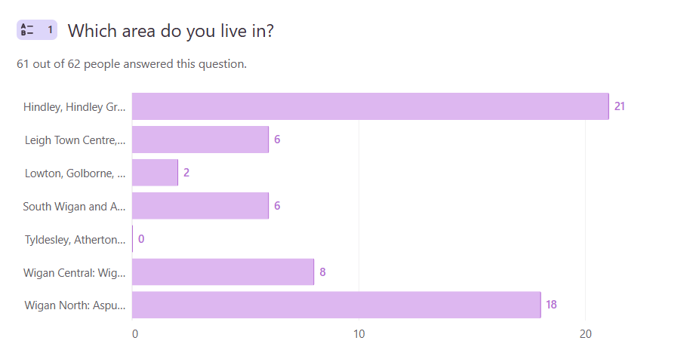
61 people told us where they live. 21 People lived in Hindley and Hindley Green, 6 from Leigh Town Centre, 2 from Lowton and Golborne, 6 from South Wigan and Ashton, 0 from Tyldesley and Atherton, 8 from Wigan Central and 18 from Wigan North.

Unfortunately, we were unable to achieve an equal split of responses from across the borough with the majority being from Hindley, Ince, Aspull and the north of the borough. This may mean we only have client feedback that represents a small number of agencies.

13(22.4%) respondents were people in receipt of support whilst 40 (69%) were family members and 5 (8.6%) friends. 4 didn’t identify their status.
76% of respondents were aged over 60 years old with 71.2% (37) Female, 26.9% (14) male and 1 preferred not to say. 10 did not complete this section.
100% were white – English/Welsh/Scottish/Northern Irish/British.

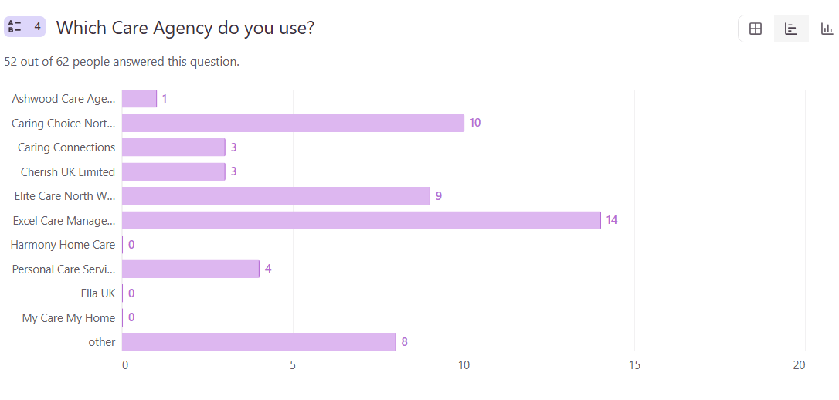

Care Arrangements:
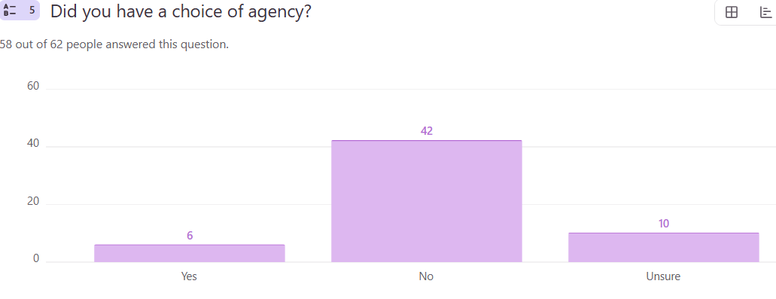

Most respondents reported they were not given a choice of care provider. Agencies appear to be geographically situated and allocated to residents within their geographical area. Alternatives were only provided where there were issues identified by families.

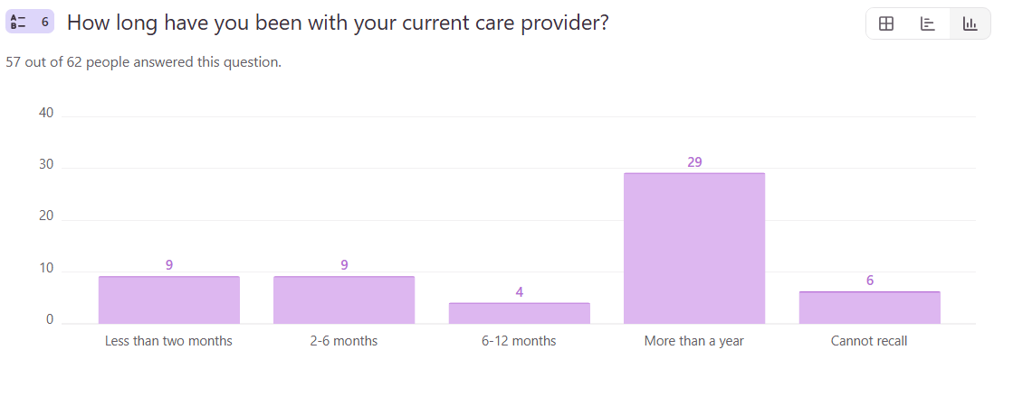

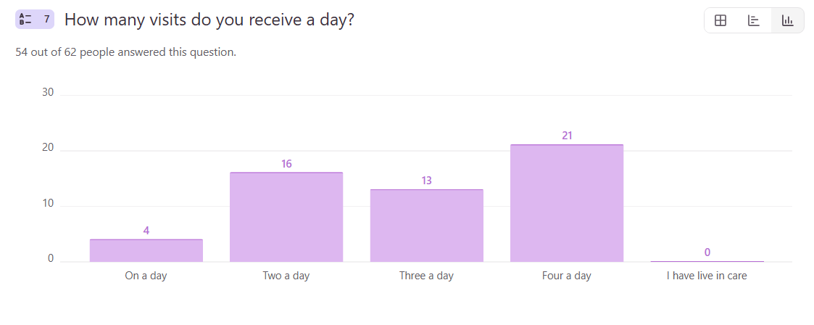

Care Plans
Were you involved in planning your care support?
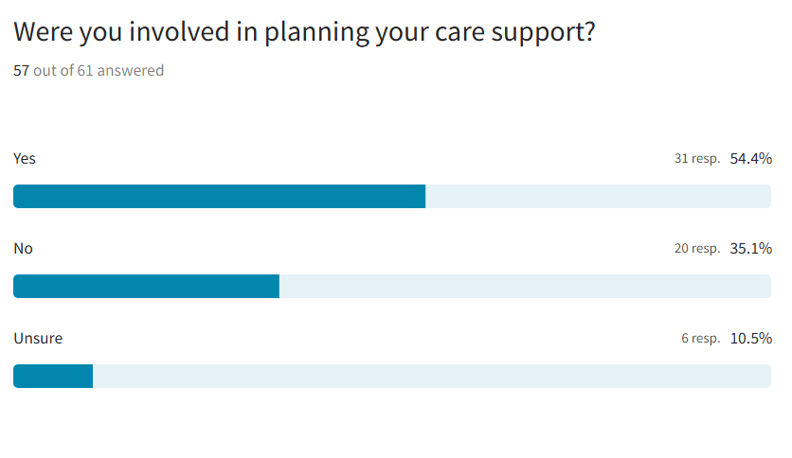
Clients felt communication was poor between hospitals, care agencies, and the council when care was being arranged. Just over 50% confirmed they had been involved in the planning of the care they or their family member was to receive. Whilst some had visits from Occupational Therapists and Social Workers to discuss their needs others had no input from anyone and felt they had no choice but to accept the care that was delivered. Families felt they weren’t always informed or listened to, even when the person needing care could make their own choices and an example of this is reflected in Rob’s story. One respondent commented:

‘The council offered only this provider. It was set up without any communication from …. I didn’t have ant information or knowledge about times, visits, that there was even an app I could have. No contact details either or name of provider.’

‘Various people from Wigan Social Services and the occupational therapist came to assess my wife for the care and support she required.’

Do you have a copy of your care plan and is it accurate and up to date?
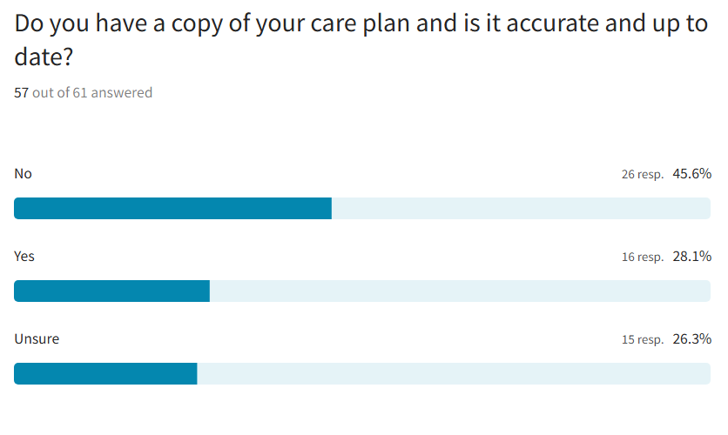
Fewer than half of respondents had access to a copy of the care plan. Some clients were never given a care plan and others reported that whilst it was available via an app, they couldn’t access it themselves. In some instances, the care plan was only available on carers’ phones through the app, which some families/service users had tried to download but couldn't.

Carers
The care worker has enough time to provide my care when they visit.
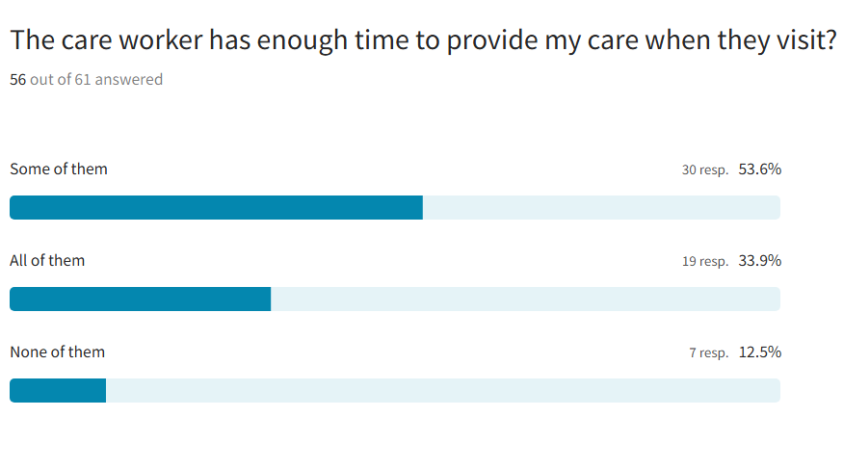
‘Depends on who it is. Some don’t even take their coat off.’
Only a third of respondents said that all their carers had enough time to deliver the required care. Clients said that the care often feels rushed because carers have too many visits and not enough time. Some stay only a few minutes, even when they're supposed to be there longer. A few carers do a great job and go above and beyond, but many seem in a hurry, sometimes not even taking off their coats. Tasks are missed or not done properly, and records on the app don’t always reflect what really happened. The app to track care wasn't available to one respondent for over a year. Although carers usually ask if more help is needed before they leave, the overall service feels inconsistent and under pressure.

‘They always ask is there anything more that they can help me with before they go.’

‘They are always in a rush despite having 30 mins slot they are sometimes only there 5 mins tops, Not great.’

If any of your visits are 15 minutes, do you feel this is enough time to support you?
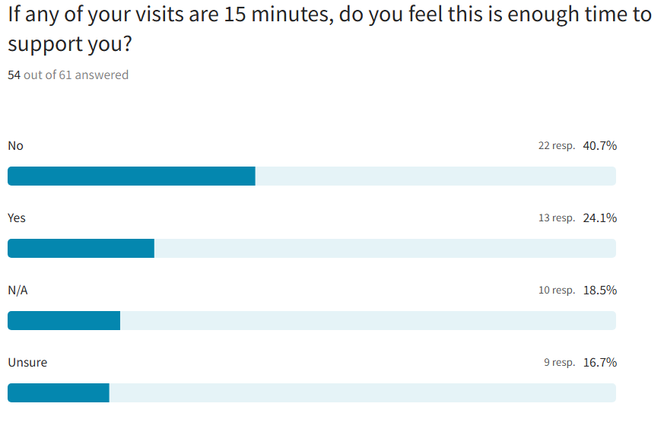
Clients told us that carers often don’t stay for the full time they’re meant to even if it is a 15-minute visit. Visits can be very short, sometimes just 5 minutes, even when 15 or 30 minutes are scheduled. This means proper meals aren’t prepared, and some tasks are rushed or left unfinished, like washing up. Sometimes carers don’t help at all and just ask if everything is okay before leaving. While a quick visit is fine for things like giving medication or using the toilet, more time is needed for other tasks. People feel there should be an option to say when visits go over or under the expected time.

‘Due to medication administering, visits are very short and less than 15 mins.’

‘Call for 15 minutes in the afternoon- wash up but don’t put the dishes away. They leave the bowl full of dirty washing.’

How happy are you with the relationship with the care workers?

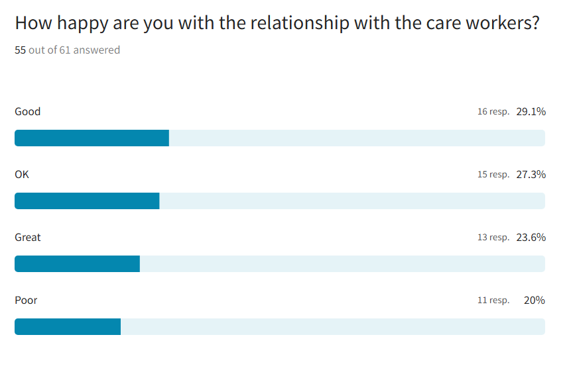
Relationships between carers and clients seem to be positive in 80% of reported cases. However, this means 20% could be problematic. Clients told us that when talking to some carers it can be hard because of the language barriers. Some carers are young and don’t connect well with the client, and a few have a poor attitude. However, many carers are kind, caring, and do a great job. High staff turnover means it’s hard to build good relationships. Some carers don’t talk much or seem to ignore the person, while others are friendly and take time to chat. Overall, experiences vary a lot, with some carers being excellent and others not as good.

‘Some carers I do not approve of or like. Some are good and nice people who care for my husband and help him.’ | ‘Some of the girls are fantastic and do a good job. Some don't care and just do all the tasks.’
‘We have 2 care workers who are outstanding. They are very gentle and caring with my wife - excellent (Claire & Caitlin).’ | ‘Some are wonderful; however, they have such a high turnover of staff they don't build relationships. Some carers don’t engage in conversation with her and talk to each other ignoring her.’

Do you regularly see the same care workers?

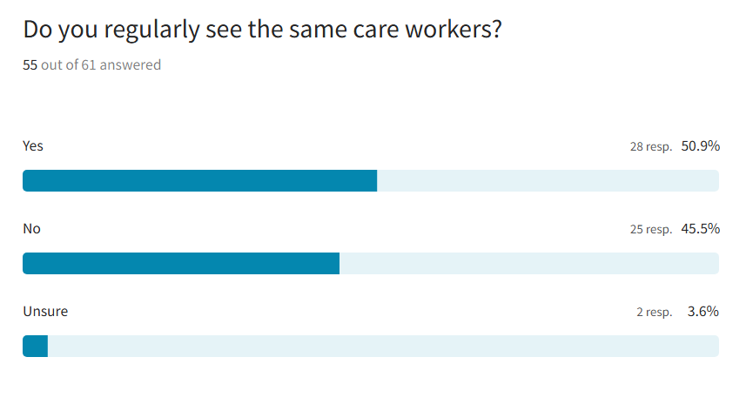
Approximately half of respondents reported seeing the same carers. Clients told us that for someone with dementia, seeing the same carers is very important, but this didn’t happen. During the week the carers tend to be the same, but at weekends there are often different ones.

‘With dementia my dad would have benefited from seeing same face but no never, no consistency’ | ‘In 22 weeks had 24 different care workers attend to client with dementia’ | ‘You will see the same girls for a few weeks and then you will get new girls who don't know you and haven't got a clue.’
‘We usually see the same handful of staff.’

Do you feel the carers who support you treat you with kindness, dignity and respect?
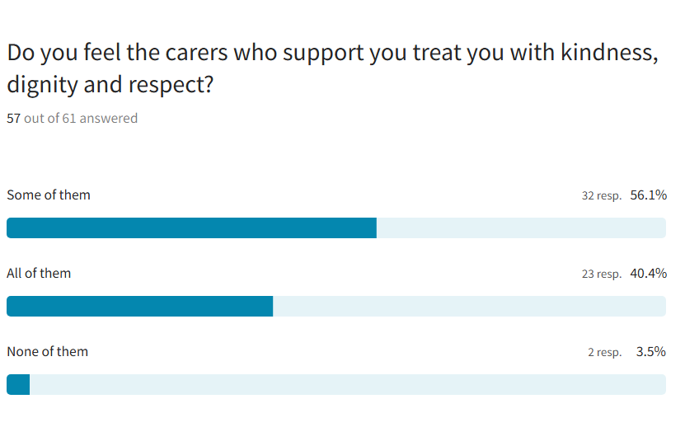
A small number of respondents reported that they didn’t feel treated with kindness and respect. Clients told us that while most carers have been respectful and polite, a few have come across as rude or not very caring, which has been upsetting. Some seem young and inexperienced and might need more support and training, especially around important tasks like handling medication safely. Overall, there are carers who do a wonderful job, but it’s clear that better training and supervision could really help improve the experience for everyone.

‘100% I could not ask for a better team of carers.’

‘One girl had no respect whatsoever one time I arrived there. Mum was anxious worrying over lost keys. She had dementia. The girl sat at the back of the room documenting in the logbook …. she laughed and said to me “I bet she annoys you when she’s like this”. I read the logbook after she’d gone. She’d documented “all fine on leaving”

‘I didn't feel like I was treated as an individual.’

Are you confident in your care workers’ ability to support you?

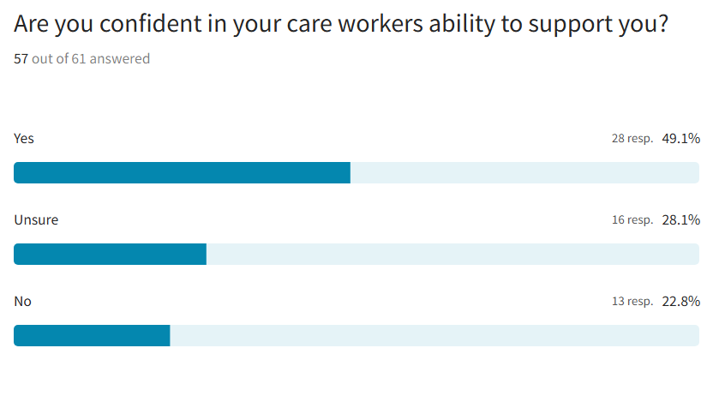
Only 49% of respondents felt confident the carers could meet their needs. Clients told us that some carers are asked to do tasks like changing stomas but haven’t been properly trained. Families often have to guide or check on the carers to make sure things are done right. Personal care, like washing, brushing teeth, or helping with hoists, is sometimes missed or done poorly. In one case, a person was left alone after a fall without help. Carers sometimes rely heavily on family support, especially for things like bedtime care. There have also been problems with carers not following instructions to get into the house and not giving medication properly, which caused serious concern to family. Overall, families feel that carers need better training and clearer communication from management to keep their loved ones safe and well cared for.

‘Some struggle to use the hoist and never brush her teeth, and sometimes don’t dry her hair’

‘Many didn’t understand my husband’s complex health needs, some couldn’t speak English, so it was hard to explain what was needed’

‘In the morning, they give my wife a good wash, dress her, clean her teeth and put her in the chair. I would find that hard to do myself.’

Are you confident the carers know how to use the equipment in your home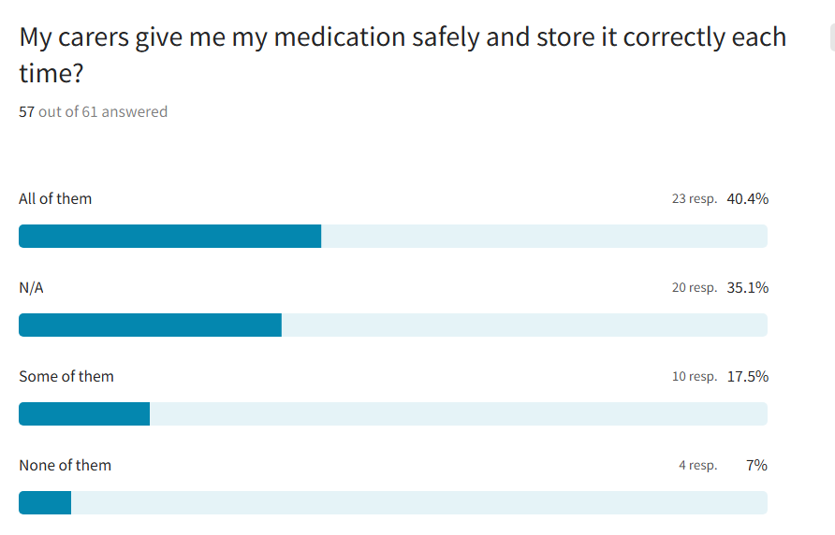
‘My mum has been on the floor twice with lack of Moving and Handling knowledge and uncertainty with machine - carers just picked her up off the floor. Agency haven’t been open and transparent or displayed duty of candour as reported the experience but heard nothing back about how they’ve dealt with it’

‘There have been 2 medication errors, food has been left unwrapped, hot drinks left unsupervised, table been placed in front of chair, commode left out, blinds and curtains left closed, soiled pads left on work top’

Clients told us that some carers are kind, like offering to make a sandwich if someone is unwell, and some families are very happy with their service. But there are problems too: food is often overcooked or not hot, and some carers don’t know how to use the cooker properly. Many struggles with using equipment like hoists, which has upset some patients. Medication is usually managed by family. However, there have been mistakes with medication reported, unsafe situations like hot drinks left unsupervised, and care tasks sometimes left unfinished or done poorly. Some families wish for better-trained carers or a different agency altogether. Overall, respondents tell us that care needs to improve, especially around food, safety, and equipment use.

Time keeping
The care workers regularly turn up at the time that I have requested.
‘They never come at the same time. Some mornings they come at 7am, some at 11am. Tea can be anytime between 4-7pm.’

‘We weren't able to specify a time. Without family getting the patient up in the morning, sometimes the carer can be as late as 11.30am so this could be very difficult for patients with less family support.’

‘This past week breakfast calls were between 11-12 noon. Which is too late for breakfast. Weekends are hit and miss, and evening times are sometimes much too late for my parent.’

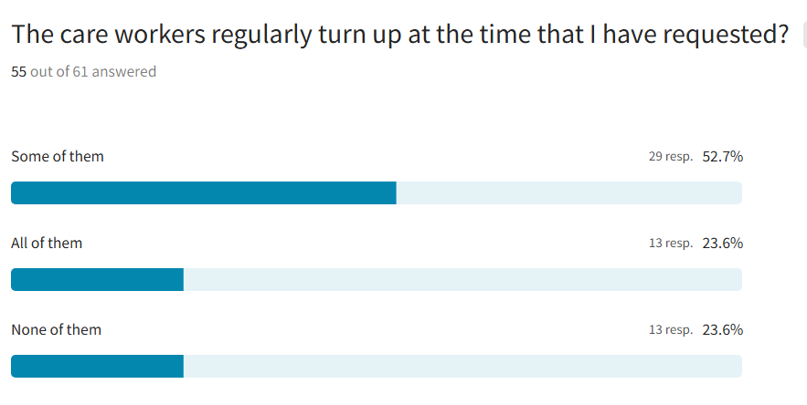
Less than a quarter of respondents reported that carers always arrive at the allocated time. Clients told us that carers often come at unpredictable times, and few people are given a choice of when they'd like their visits. Sometimes visits are too early or too late, like breakfast arriving at noon or bedtime calls happening at 7pm or even earlier. This makes it hard to plan meals, personal care, or daily routines. The timing varies a lot from day to day, and it’s especially difficult on weekends. Many people have had to chase the agency multiple times to try to fix the visit times, but changes are slow or don’t happen. While carers report delays due to traffic or other clients needing extra help, the system feels unreliable and inconsistent for many. There were reports of carers arriving for a breakfast visit near dinner time and then ‘doubling’ it up with a lunchtime visit and likewise tea and bedtime. This has consequences for medication administration especially if a time critical medication is required, as well as providing appropriate nutrition and hydration if clients are dependent for this on the carer. Further consideration relates to financial contributions as clients pay for a service they perceive they are not receiving.

Do the care workers stay for the agreed amount of time?
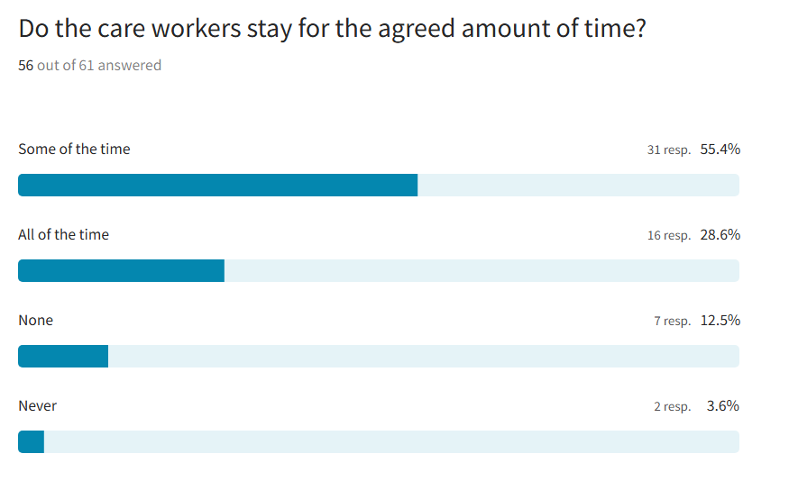

Clients shared with us that care visits often feel rushed. Carers sometimes stay much less time than they’re supposed to, like 10 minutes instead of 30 or 45 and sometimes only one carer shows up when two are expected. Families often need to step in and help, especially when tasks are missed. A lack of involvement in planning the care and support required often means there has been no chance to agree on how long visits should last. In some cases, carers leave quickly after giving medication, likely because they’re busy with other clients. Some carers are willing to chat if they have time, and on quieter days, shorter visits are fine if there’s not much to do.

‘No, they have to try to keep everyone happy’

‘We have never had an opportunity to agree how long they should stay’

Changes to care
Are you informed before a visit if there is going to be a change in who will be visiting you or if they are going to be late?
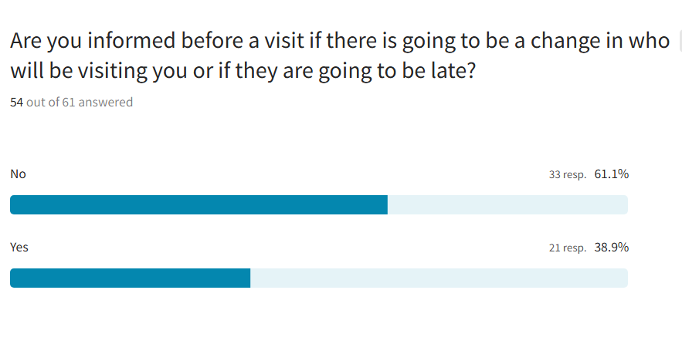
Less than 50% of respondents tell us they are informed of changes in carers. Clients shared with us that people often don’t know which carer is coming or what time they’ll arrive. Sometimes they get a call, but not always. There’s a lack of clear communication, which can be confusing, especially for the person receiving care. Some providers do better than others; for example, one mentioned that communication with Elite is very good. But overall, changes in carers and visit times happen often without notice, and families usually need to call to find out what’s going on. Respondents reported the distress this can cause if visits are cancelled and the impact this can have on families who may have to fill a gap at short notice.

‘We are never informed who will be visiting or at what time they will be coming.’ | ‘Yes and no. I have an app with name and estimated times of carers and the actual time they arrive.’

Missed visits
In the last 12 months have your carer visits been missed, or have they not turned up at all?
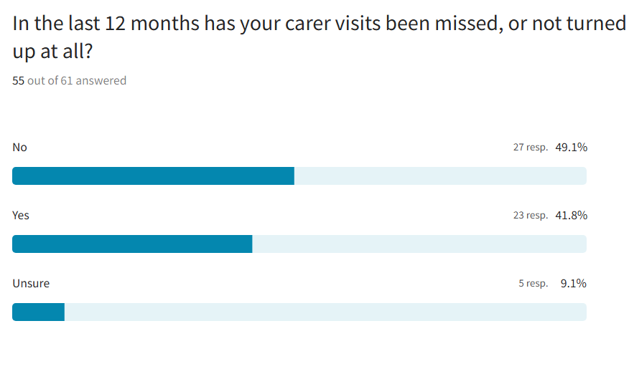
Clients told us that sometimes visits are cancelled by choice when the client’s family is visiting. However, there have also been missed or combined visits due to staff shortages, carers calling in sick, or other issues like car problems. Often, there’s no warning that a visit will be missed, and communication can be unclear. While missed visits don’t happen all the time, they have occurred a few times and caused confusion or concern for the client and/or their family.

‘On the odd occasion because of shortage of staff, breakfast and dinner calls have been combined. Carers don't stay any longer though.’

Home care managers
As a manager what are the biggest challenges you face when recruiting.
Recruitment and retention of carers is challenging due to low candidate numbers and high advertising costs. Many carers prefer to work in care homes to avoid using their own vehicles, which makes carer roles less appealing. Additionally, staff often change their working patterns and may be unwilling to follow set procedures. Benefit entitlements can restrict the number of hours staff are willing or able to work, and some request impractical schedules, such as working over only three days within limited hours. The high level of responsibility expected of carers can be overwhelming for some, leading them to consider roles in other sectors. The impact of COVID19 has also had lasting effects on the ability to attract and retain care staff.

‘Recruiting carers and getting them to stay, carers seem to want to work in a care home, so they don't need to use their own vehicles’

‘Limitations on the hours staff can work due to benefit entitlements. Staff may also state they would like to work 30 plus hours but over 3 days between the hours of, for example, 10 and 2.30 pm, which is impossible to fulfil. The amount of responsibilities that are expected of carers can be extremely overwhelming to some recruits and they feel that a different position in another sector may be more suitable for them. COVID also had a huge impact on the recruitment of staff.’

‘Not enough candidates coming through, cost of advertising’

What steps have you taken to help staff stay longer in their roles?
‘We accommodate their needs/working hours to suit their home/family life’
‘Open door policy within the branch, person-centred training, staff appreciation presentations, incentives such as free blue light cards, Costco memberships, Wage stream, VIV up, regular team meetings, regular check-ins.’

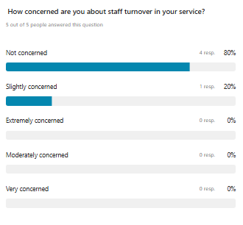

We provide ongoing training and support to empower staff, with a strong focus on work-life balance. An open-door policy, person-centred training, staff recognition, and incentives like Blue Light Cards, Costco memberships, Wage stream, and VIV up help adopt a positive work environment. Regular team meetings, check-ins, and flexible planning further support staff in balancing their professional and personal lives.

What training do you think is missing or could be improved?

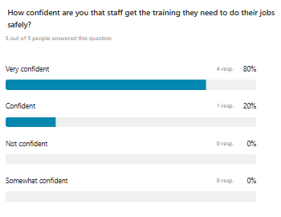
‘We are working on a new training schedule, and things can be added when required to the online aspect’

There was a high level of confidence that staff get sufficient and appropriate training to fulfil their roles. One manager reported they were creating a new training plan and can add more online courses as needed.

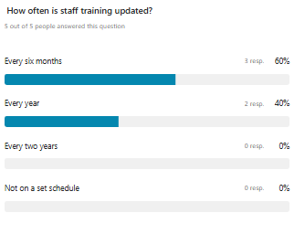
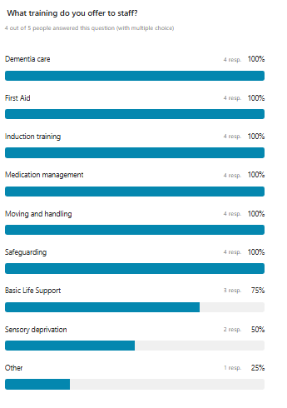
While not all training options were listed, agency staff tell us that they do provide all required training, including the Care Certificate, NVQs, and hands-on sessions like personal care and cooking.

What extra support would help you keep staff and grow their skills?
Paying staff more and offering training courses (not just for senior roles) could help keep carers in their jobs, especially during times like summer and Christmas when many tend to leave. Helping younger carers get recognised qualifications can give them a clearer path and make them feel more valued. Staff leaving has always been a problem in care but giving people more chances to learn and grow might help them stay longer.

‘Higher wages’
‘I do feel that supporting staff to achieve recognised qualifications can provide a sense of direction, particularly for the younger carers. I am unsure of what extra support could be offered.’

If you could improve one thing in the Home Care Service what would that be?
Carers should be paid fairly, and people receiving care should be able to choose which agency they want. Social workers need to better understand the challenges care staff face. It would also help if care providers were more involved in planning before someone leaves hospital or starts care. Finally, many families don’t fully understand what home care includes, which can lead to unrealistic expectations.

‘Service users should have freedom to choose which agency they want to go with’
‘To be more involved in discharges and initial assessments before excepting a package’
‘This is a difficult question. I do feel that there is often a misconception of what Home Care. What families, and service users may expect of a carer is not always what homecare is.’

Care Staff

Do you feel that you have enough time to complete your work?

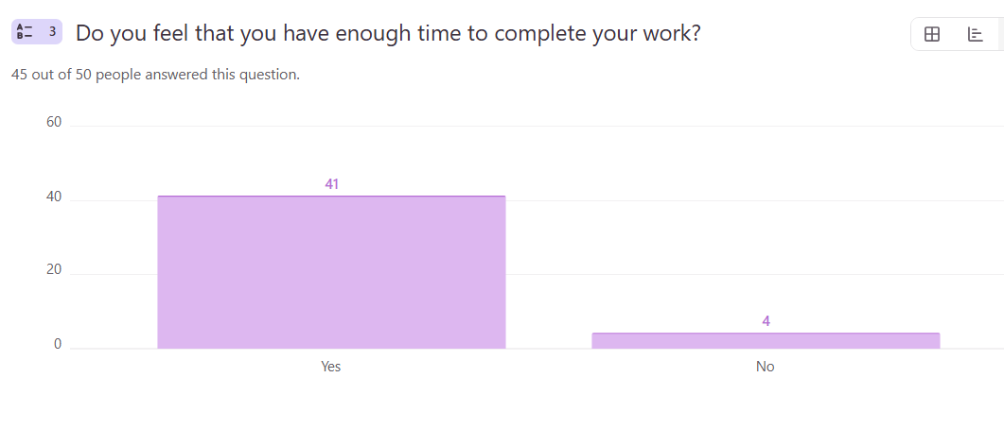
The staff commented that the agencies are seen as supportive, client-focused, and caring employers. Staff feel that they are respected and valued, and they appreciate the time given to deliver quality care. There are some minor operational challenges (like tight scheduling of the work or occasional overlapping calls), but they don’t outweigh the overall satisfaction of working at the agency.
Person centred care is upmost focusing on what the service users need. Elite emphasise the importance of advocacy and integrated care even when we as carers are ignored at times by other agencies we are encouraged to keep trying’

‘Service users are a priority for the company, and this shows when a call needs more time or less time it's reviewed constantly, and the managers speak to the appropriate professionals to ensure changes for the service are made with them as priority.

Do you involve the people you care for in how they would like their care to be provided?

Staff commented that they consistently prioritise person-centred care by involving each client in decisions about their support. They ask how the client wants things done, encourage independence by getting them to brush their hair or dress themselves, and tailor their care plans to their needs and preferences. Consent is always sought from the client, and if something can't be done safely or is outside a staff member's role, it's reported to the manager and let the person receiving care know and explain why it cannot be done. Their focus is always on respecting the person, promoting confidence, and delivering care that suits them.
‘Yes, initial assessments are completed with each service user. Their views, values, preferences and care needs are discussed at length then written into a care plan to disseminate to staff.’

‘Person-centred care is encouraged, and I always complete care for the service users how they would like it to be completed as long as safe and within my scope of practice, if unable to I report this to the managers and explain to the service why this cannot be completed in such a way.’

‘I've only been with Elite for a short while, but I've been made to feel very welcomed. Everybody is so helpful and will help wherever they can, rotas are never unmanageable and packed with calls’

Do you receive training in all aspects of your role?

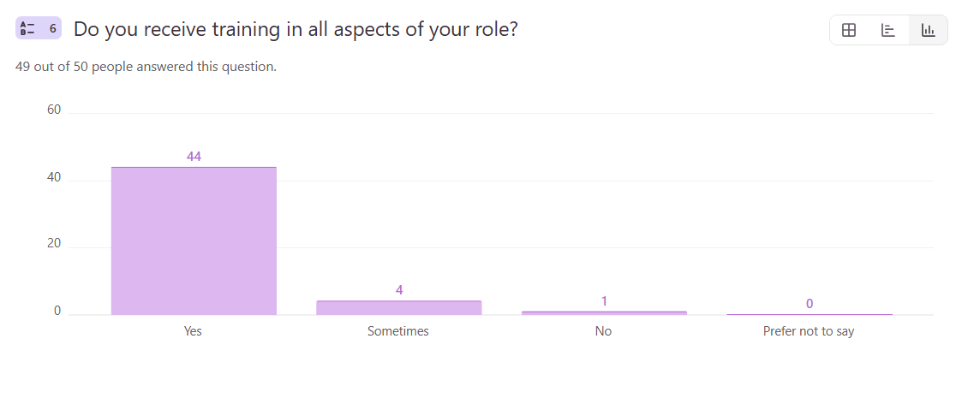

Overall, the staff are positive about their training, they feel confident and well supported. They're given all the necessary training to do their jobs well, including extra training like sign language or PEG feeding when needed. If they work with clients who have special needs, they’re trained before starting. However, a few people mention that there's some equipment they haven’t been trained on, and they’d like more training in specific areas. (Specific areas not stated)
‘All training is completed with additional training if we require it or want to complete this such as sign language and peg training’ | ‘There is some equipment I have never used or been trained on’ | ‘Would like more training in certain areas’

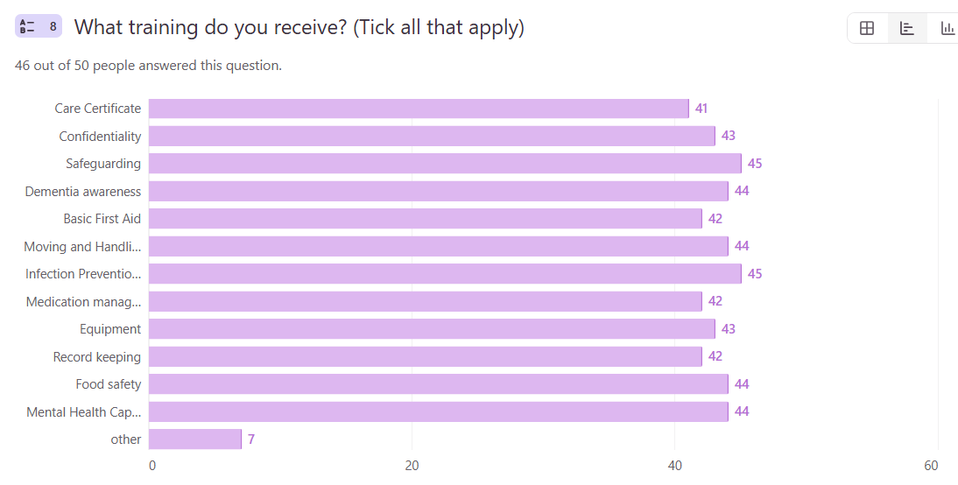

What further training do you think that you need?
Staff suggested training around
- Stoma care equipment
- Mental health
- Peg training – using external feeding tubes
- Medication awareness
- Dealing with difficult behaviours
- First aid
- Extra training around Dementia
- Refresher on all systems, how the trackers are wanting to be completed and how audits need to be completed
- Choking hazards
- Oliver McGowan training - a mandatory learning disability and autism training programme for health and social care staff in the UK.
- NVQ
- Moving and handling
Some staff said that they were adequately trained and were confident in what they were doing

Do you encounter any communication barriers with the people you care for?

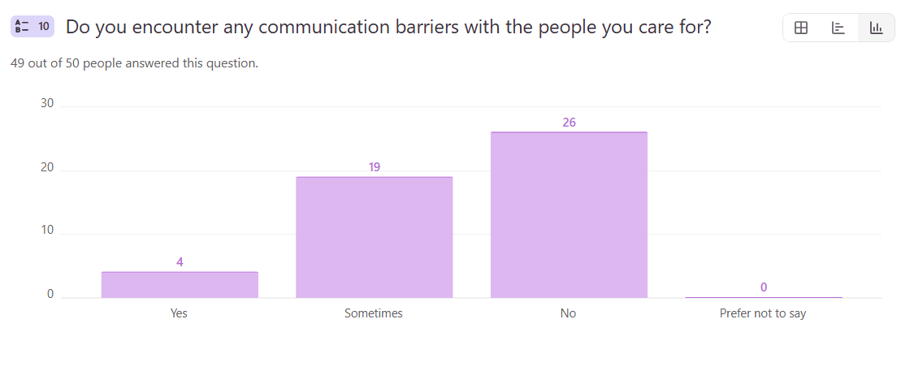
Staff commented that some of the barriers with people that we care for include limited support from district nurses, particularly regarding changing soiled dressings and collecting catheter specimens of urine (CSUs) which can lead to delayed treatment and health risks like kidney damage or infected pressure sores.
Communication challenges are also significant, especially with clients who are deaf, hard of hearing, non-verbal, or affected by conditions like dementia or stroke. Staff overcome these by using clear, person-centred communication, assistive tools (e.g., whiteboards, speech aids), active listening, some patience, and adapting to each person’s individual needs.

‘Hard of hearing, Dementia and strokes are all barriers to communication. Having patience and allowing time to communicate is key’

Do you feel that you receive enough support from the agency that you work for?

Most members of staff feel very well supported by the agency, especially by the managers. They describe the agency as brilliant, approachable, and helpful, both in work matters and personal issues. People like the open-door policy and regular check-ins.
They also mention that staff help each other out and there's a strong sense of teamwork.
However, a few concerns were raised:
- Constantly have to translate when they can’t understand carers whose first language isn’t English.
- Not enough training in some cases.
- They feel at times health could be taken more seriously and understood more as certain conditions are sometimes brushed over as not being serious and the individual is not cared for or given support.
- A couple of people said they feel supported “sometimes” rather than always.
Overall, this feedback is largely positive, but there's clear room to enhance training and inclusivity.
‘From the agency yes from other care services no’

‘Yes, the management team are brilliant. They complete check-ins, have an open-door policy and ensure I am supported in every aspect of my role.’

Do you care for any clients with sensory/physical or long-term conditions?

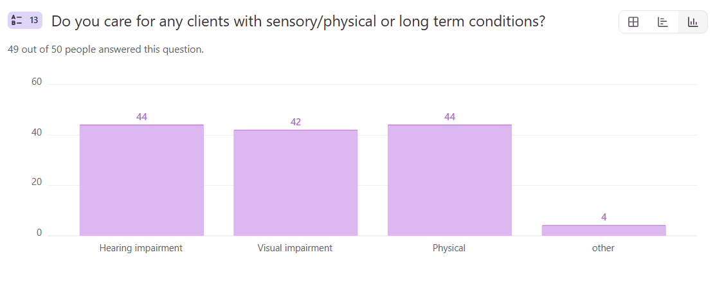
If you have answered yes to the above question. Have you received any specific training related to the needs of the individual client?
The majority of the staff said they had received specific training to support the client such as:
- Sign language
“Moving and handling assessments have been done and placed in care plans for those with physical limitations. For hearing and sight impairments, assessments are conducted on how they prefer to communicate and how they wish care to be delivered. This can all be found in the care plan”

- Moving and handling
- Care plan states how best to communicate
- Specialist autism training
- Demetia training


Is travel time factored into your workday. If so, how does this work?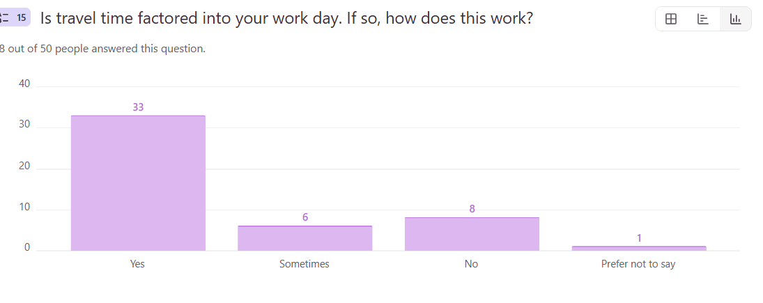
Staff comment that travel time is usually included in their schedules and generally works well. However, sometimes there are problems and calls are too close together or even overlap, making it hard to get from one client to the next without rushing.
Some staff say they aren’t fully paid for all the time spent travelling in traffic and long walking distances, which also can cause delays arriving at the client’s home.
‘Often calls start the second the previous call ended. Sometimes 5 minutes may be given, however, sometimes two calls are scheduled for the same time. Therefore, those 5 minutes no longer matter’
‘Yes, your clients are spaced out with appropriate travel time, which works most of the time.’

What do you do to make sure the people you care for at home are safe and well looked after?
Staff provide
- high-quality, person-centred care by following each client's care plan, meeting their individual needs, and treating them with dignity and respect.
- ensure their client’s home is clean and safe, tasks are completed properly, and they feel comfortable and secure.
- report any changes or concerns to the office, involve clients in decisions, and promote independence.
- always lock up, return keys, and make sure everything is left safe before leaving.
- Communication, compassion, and professionalism guide everything they do.

‘Ensure safe practice & clear communication as well as ensuring I promote as much independence as possible with a person’s abilities.’

‘I make sure I follow their care plan and treat them with dignity and equality, am a good listener and compassionate, I take care of every client according to their respective needs’

Overall, are you satisfied with the agency that you work for?

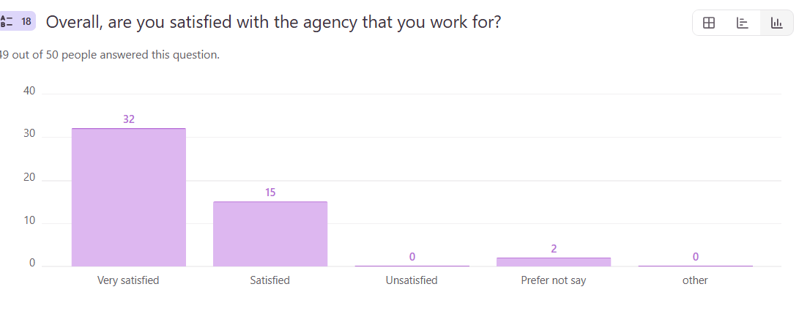
Staff feel supported, valued, and part of a caring team particularly at Ella UK, with strong job satisfaction and pride in delivering quality care. However, some staff raised overall concerns about low pay and insufficient travel expense reimbursement.

‘I’ve worked for them for 12 years, love job and my clients.’

‘I am disappointed with considerations regarding using own vehicles to travel between calls. Fuel allowance does not cover the cost of wear and tear of personal vehicles.’

If you could make one improvement to the Home Care Service what would that be?
Some of the suggestions made regarding carers perceived improvements:
- Better awareness of what the job involves - especially the younger carers, they don’t understand the full importance of the role
- Offer more night visits to clients who need extra help during the night
- Increase the pay for home care workers across the board. Home care workers go above and beyond to ensure person centred care is delivered across the borough, enabling service users to remain in their home until their final days.
- More funding
- A pay rise
- Sometimes calls don’t follow on as they should, but I always report them to the office, and it is resolved
- To make it more affordable and better pay for carers.
- Put in more effort and pay more attention while working
- Have more training by senior staff who know that client. Hire people who are actually caring and interested in the job!
- Go back to face-to-face training and remove online e-learning
- Clients to have 30 min calls instead of 15 when they have multiple tasks to complete as they can’t do it in 15.
- Listen to your carers
- Some clients do complain that changing their carer makes them lose confidence and trust in the carer. They believe seeing different faces everyday will not make them free and have confidence in the care the carer is providing, So I will suggest if 2 to 4 carers can be attended to certain clients for some months before changing the carers for another set for carers.
- Be in the same area all day
- Stop providing care for people who don't need care.
- Ensure all clients would have female and male carer, not ask for female only unless they been affected by abuse
- Physical and mental health to be taken more seriously and respected.
- Every home care provider had more recognition for the care they provide in the communities.
- Improve communication with us.
Some of the staff members felt that nothing needed to be improved with the service they provide. That they are very happy in their job, they never feel ignored if they have a problem, it is always sorted out.

“All clients get good quality care.”

Demographics of care Staff
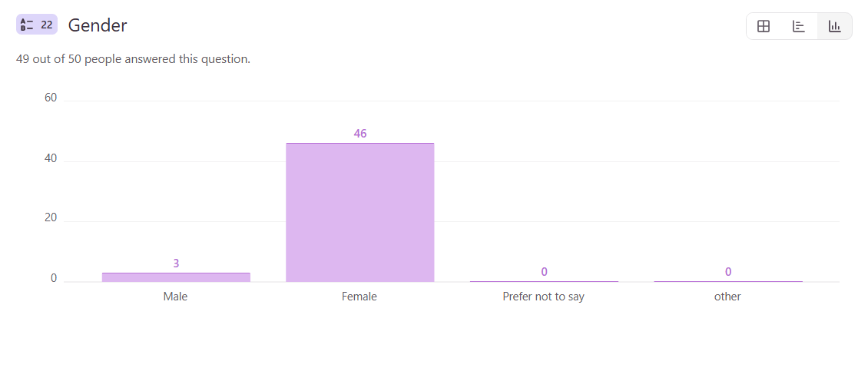
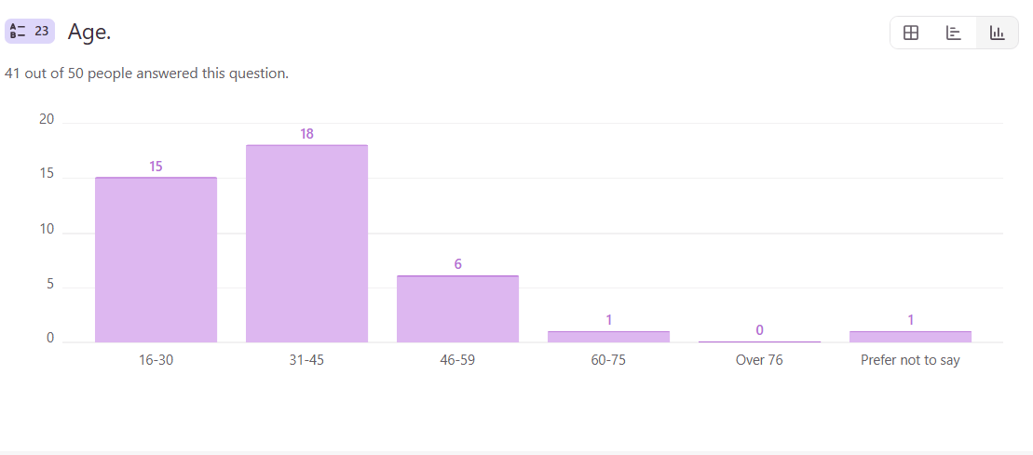
The graphs above shows that most care staff that responded are female with a very small minority being male. The staff group is made up of workers from across the working age spectrum but largely between 16 and 45.
The graph below demonstrates the ethnic make-up of respondents with most being white British.

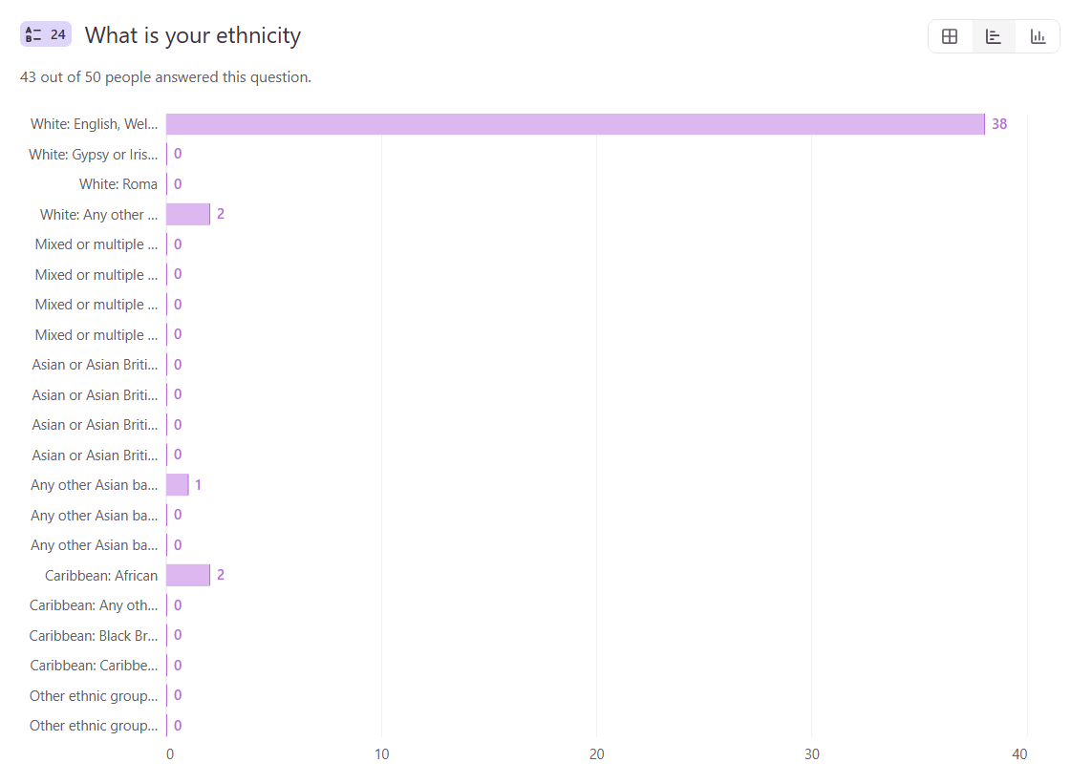

Rob’s Story
Robert was a 69-year-old man who lived with his wife. Rob had long term health problems and been supported by his wife for many years.
In December 2023 Rob had a fall at home and was admitted to hospital. He required surgery to pin his femur in January 2024. He then spent 6 weeks in rehabilitation before being discharged home.
Rob lived in a bungalow and had been a wheelchair user for approximately 15 years. On discharge home a care package was arranged by Wigan council for personal care requiring hoist transfer 4 times a day, with 2 carers.
Rob’s wife tells us ‘The care agency was imposed on us as they have the sole contract for the area we live in. No needs assessment was made and no visit by a care manager or coordinator’.
Initially the same 2 carers provided the morning and lunchtime calls, which was mainly personal care as Rob was now bladder and bowel incontinent. The method they used to transfer Rob differed between the morning /lunch time carers and those attending at tea and bedtime with Rob preferring the one used later in the day. He found this more direct and less stressful. When Rob started to ask for this method all the time, they approached the care company who agreed this was a safe method of transfer and was confirmed with both their moving and handling assessor and Wigan council’s. However, the morning carers didn’t agree with this method and stopped attending their sessions. Rob’s wife states:
‘Their unnecessary insistence in always using the bed as a method of transferring made him feel vulnerable and often led to avoidable incontinence’.

Rob found this method of transfer in the morning very distressing and undignified and was upset that his wishes were not considered. Rob’s wife felt the carer had very fixed ideas about how care should be delivered, and this prevented any individualised approach for Rob. The care agency informed Rob and his wife that they could not compel the carers to do the preferred transfer. This left 2 weeks of extremely erratic care with no consistency in time or carer. There were multiple carers attending with breakfast calls being anytime between 7am and 11am and evening between 8pm and 11.30pm. In addition, there were language barriers as some of the carers did not have English as their first language.
The carer who wrote his care plan did so without consultation with either Rob or his wife, who has cared for him for the past 25 years.
Rob’s wife tells us:
‘I reported all my concerns to the social worker, and we had a meeting with the care coordinator who tried to make out carers didn’t want to come here because of my attitude. The quality assurance team at Wigan council investigated the issue but I felt their sympathies lay with the care company rather than Rob and me. A meeting was held with them and a representative from the agency. I was made to feel that requesting a service we were told was possible was in fact impossible and I seemed to be blamed for this.
Ultimately this left us with no care for my husband and due to a health issue not picked up by the carers my husband was back in hospital and had no choice but to go to a care home while a ceiling hoist was arranged for our home in the hope that a company could provide a single carer to help with his care.
A key safe had been provided for access when Rob’s wife was out. She reports that the keycode was shared between multiple agencies and there were occasions when people just let themselves into their home even when she was there.

The care agency handbook which was provided for us states under ‘my wishes:
- A time we agree, control of my care, flexibly from carers’
The statement of purpose states:
- ‘Fully support client independence of choice’
The philosophy of care states:
- ‘Achieve optimum wellbeing, support individual choice and decision making, respect and encourage independence’
And most important to us under Supporting independence:
- ‘Take risks based on your own informed choices, including calculated risks’
There are many more statements that the company provided but are not adhered to by the carers.
Rob was again discharged home with support from an alternative agency and care went well until he was re-admitted to hospital with pneumonia. Sadly, Rob did not recover and died in November 2024.

Conclusions
Overall, the response from service users, agency managers and care staff was disappointing.
Despite seeking out groups that were likely users of home care services and seeking support from carer groups, volunteer groups and the local council, this group of service users remain hard to engage with. Therefore, it is difficult to really understand the experiences of recipients of home care. Having said that, there are several themes coming out of the data.
- Choice of agency – agencies are geographically located and commissioned therefore there is no choice for service users.
- Timing of visits – not all agencies appear to agree the timing of visits and people are at the mercy of the agency as to timing of care and meals. This raises the question ‘is person centred care really being delivered?’
- Consistency of carers – whilst some people have a small group of consistent carers, others seem to have several different staff visiting. This can be especially difficult for people with dementia and those receiving personal care.
- Late and/or missed visits – respondents reported that visits can be ‘doubled up’ at times, merging breakfast and lunch or teatime and evening visits. This is an area that needs review as this will be affecting those with greatest need requiring four visits per day. These service users will potentially be missing meals, drinks and possibly medication, therefore it is a potential safeguarding issue. Further investigation is required regarding the financial implications if people are contributing to an assessed care package but not always in receipt of it.
- The quality of care varied—some carers were kind, others less so.
- Complaints often went unheard.
- Overall, people wanted more involvement, say, better communication, and more consistent care.
Given the limited response from agency managers and the limited number of agencies that shared the survey with their staff, it is difficult to draw any general conclusions. Both managers and staff report they are largely satisfied with the training available. However, care staff felt there were some areas where additional training would be advantageous.

Agency managers felt that earlier involvement with potential clients would be of benefit when agreeing to a care package and they specifically indicated that prior to discharge from hospital would improve the service.
Agency managers reported some challenges associated with recruitment due to low numbers of applicants, benefit limitations in working hours and reluctance for staff to use their own transport for work. Pay was also mentioned along with a perceived lack of career progression.

Recommendations
HWWL recommend the report is shared with Wigan Borough Adult Social Services as the commissioner of care packages for Wigan residents.
It is recommended that the report is shared with the 8+2 ethical care providers to explore the extent of the identified issues across the borough.
Wigan Adult Social Services should as a matter of priority, explore the extent of the ‘doubled up’ visits for those residents who require three or four visits per day to see if any resident has suffered harm, with particular focus on nutrition, hydration and time critical medications. Action plans to be identified and implemented to prevent this happening again in the future.

When reviewing the report, consideration should be given to:
- The client/family to be involved the in the care planning and a choice of care provider should be offered to recipients of care wherever possible.
- All clients and (where requested and agreed) family should have access to a copy of their care plan so all parties are clear on what is to be delivered by who and when.
- Within reason, times of visits to be agreed with client/family and Carers to turn up at the agreed time and stay for their allocated time so the care doesn’t feel rushed. This would prevent doubling up when they are paying for four sessions when on these occasions they are receiving less.
- Improved communication between carer, management and the client/families to keep them safe and well cared for. Ensure regular reviews are held as identified within the commissioning agreement.
- If there are missed visits, should/do the clients receive a refund? Clarity to be provided to clients and families where there are incidents of ‘doubled up’ or missed visits.
- Staff have identified they would like/require additional training in specific areas, especially on equipment they may not be familiar with.
- Tight scheduling of work or overlapping calls need to be reviewed to reduce pressure on staff and reduce incidence of calls being cut short or doubled up.
- It is not clear if the use of translation services for people whose first language is not English are available.
- Every effort to be made to ensure gender specific requests are met when allocating carers to clients.
- The relationship between the client and carer is vital in ensuring high quality care and staff developing the knowledge of the client and early awareness of changes in a client’s condition. This is especially important where the client has a diagnosis of dementia. Both care staff and families have raised concerns about the frequency of changes in care staff and the numbers of different staff who visit. Every effort should be made to limit the numbers of different staff allocated to clients with dementia, so they become familiar with each other and the client feels safe and well cared for.
- Paid travel time between visits for staff.

Each agency has a Qualiry Performance Officer link with Wigan Adult Social Services. It would be useful to share the findings from this report with this group. If these issues do not form part of the current quality performance framework, then consideration should be given to adding relevant areas of concern to future quality reviews.

Acknowledgments
Healthwatch Wigan and Leigh would like to thank those clients and families who took the time to complete the survey and share very valuable information about their experiences of receiving Home Care in Wigan. Thanks also go to those people who were happy to share their stories in person at the groups we attended across the borough. Particular thanks go to Rob’s wife who shared their very distressing experience, and we hope this report goes some way in preventing similar experiences for others.
We would also like to thank those Home care Agency managers and staff who shared their experiences. Hopefully the information they shared and suggestions they made will inform home care services going forward.
Also, a very special thank you to Healthwatch Wigan and Leigh staff and volunteers who supported and gave up their time to work on the project and to our Advisory Committee Volunteer Sponsor for supporting the project.

